Child nodes sequence is different from Original prod file and trimmed file.

Original Prod file:

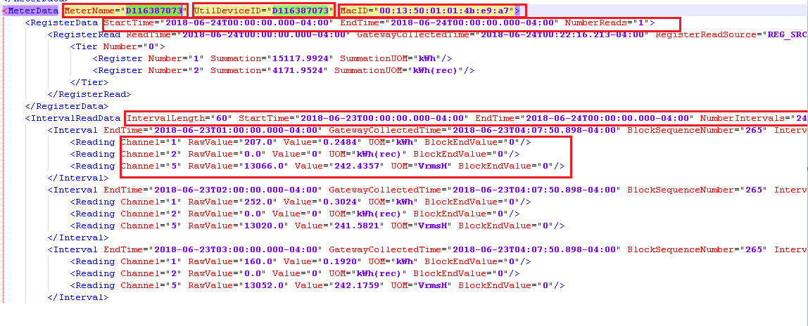

Output - Trimmed files: (node positions is not correct; expected: should be same as above)

